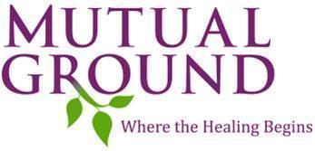

**Personal Body Safety Program**

**5th Grade Booster**

1. Introduction
   1. Safety program about touches
2. Ownership of their bodies
   1. You own your body
   2. Important to keep body safe
3. Types of Touch
   1. Safe – feel cared for and loved.
   2. Unsafe – hurt your body and feelings.
   3. Uncomfortable – feel confusing and mixed up.

# Consent

* 1. Definition & Discussion

1. Personal Boundaries
   1. Definition & Discussion
      1. Self-created
      2. Need to be respected
      3. Can change
2. Instinct
   1. Definition & Discussion
      1. Bodies alarm system.
      2. Feelings as warning signs to tell an adult.
3. Identify Private Parts (parts of your body covered by a bathing suit)
4. Personal Body Safety Rule
   1. “No one should touch your private parts, except to keep you clean and healthy”
5. Self-Empowerment/What to Do
   1. Personal Body Safety Plan
      1. Yell “No”
      2. Get to a safe place.
      3. Tell an adult.
6. Trusted Adults
   1. Who are trusted adults?
   2. What to do if a trusted adult is unavailable.
7. Secrets
   1. Safe Secrets
   2. Unsafe Secrets

### Grooming / Tricks

1. Safety and Technology
   1. Emphasize the importance of being safe online.
2. Video: “Digital Citizenship for Kids”
3. Identification of Fault
   1. Unsafe & uncomfortable touches are always the offender’s fault.
4. Activity: “Acting Lesson Scenario”